One Day WoW Planning
FACILITATORS NOTES
Learning Objectives
To feel confident and prepared to co-deliver a 1 day WoW workshop

Time | Programme | Activity | Resources | Lead
20 mins | Introduction to session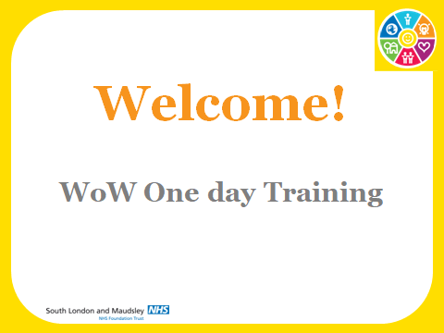 | Welcome back  Acknowledgement of traditional owners  Housekeeping  In a circle to reconnect with each other.  Explain circle. How am I feeling? Pick a card that represents. | Post-its  Pens  Photo cards
5 mins | Meditation | Body Scan
2 mins |  | Aim of the training is to equip you with the knowledge skills and abilities to deliver the WoW one day program.  (Reiterate that they’ve had a range of activities and  The day will follow the following format…..  NB constructive feedback welcome  We will break at about 11am and 12.45 and aim to finish at 3pm
25 mins |  | Catch up:  - In pairs share how you have been using WoW since we last met (10 mins)  - what's worked best for you/Learning?  - One thing to share with the whole group? (15 mins)
8 mins | Overview of Program  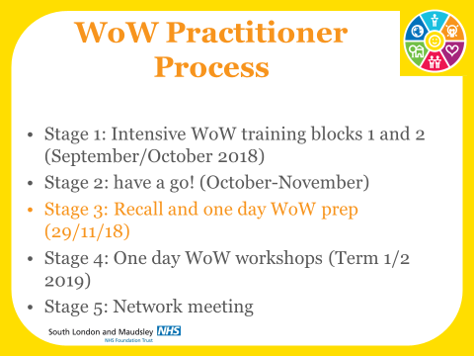 | - We are now on stage 3 learning to run the One day WoW.  - The one day WoW session is a collection of 4 WoW activities that you experienced in block 1 and 2 of the training plus one new activity – the WoW market place.  - The one day WoW is just an example of how you can put WoW activities together.  - The main purpose of you running the one day WoW is for us to see you in action and provide feedback. It enables us to verify you to use all the WoW resources.  - The training today is an opportunity for you to practice running the one day WoW, ask any questions that you may have and then plan your workshop
5 mins |  | As part of the verification process you are required to keep a learning log.  It’s a self assessment and you will send it to your advanced trainer after you have completed the one day WoW workshop  There are 4 key learning objectives for you to fulfill:  1.Knowlege and understanding of wellbeing and happiness  2. Knowledge and ability to use Wow resources effectively  3. Facilitating and running a one day WoW workshop  You tick the box with the relevant learning source and then describe in the personal reflection. There will be opportunities both today and after the one day WoW for both peer and tutor feedback.  There is also a section for Tutor comments and personal development needs.  You will need to submit your Personal learning log to your advanced trainers by the beginning of May at the very latest.  Any questions about learning logs?  Questions about 1 day WoW? Any burning questions that may need to address now?
30 mins  15 mins trainer  15 mins prep  Delivery of sections |  | Trainer talk through the program and key messages  - PE – q’s you might ask  - Key Messages  - behavior change and positive emotions  - What is happiness – pleasure, passion and higher purpose  In training teams run through the facilitators notes sessions from Welcome to first break:
Break 15 mins
60 mins  60 mins  Delivery and feedback (20 mins x3) |  | - Ask each trainer to talk through their section – any questions (20 mins)  - Invite each group to deliver their section/presentation to the whole, group who will role play. They do not need to run the activity but more present and giving feedback  - Background to WoW presentations– Team 1 = 10 mins  Whole group feedback -5 mins  - Positive emotions – interactive presentation – Team 2 – 10 min  Whole group feedback – 5 mins  - What is happiness? – Interactive presentation – Team 3 – 10 mins  Whole group feedback – 5 mins  Anything else from session 1 people want to ask about?
30 mins |  | Trainer talk through the program and key messages  In training teams run through the facilitators notes sessions from break until Lunch:  - Ask each trainer to talk through their section – any questions (20 mins)  - Invite each group to deliver their section/presentation to the whole, group who will role play. They do not need to run the activity but more present and giving feedback
- LUNCH 30 minutes Play the game over lunch everyone to have a go - 4 games at tables
60 mins |  | - Why bother presentation – Team 4 = 15 mins  Whole group feedback -10 mins  - 50:40:10 – Feedback only – Minnesota twins study – Team 2 – 10 min  Whole group feedback – 10 mins  - What makes most people happy? – get people to call out a card for people to talk to – Team 3 – 15 mins  Whole group feedback – 10 mins  Anything else from session 2 people want to ask about
60 mins |  | The market place:  Run the market place 45 minutes  Take feedback – 15 mins  How do people feel about running the market place? Any Questions?  We will be there to help set up  Action Planning
30 mins |  | In Teams
10 mins |  | Any questions ( 10 mins)  How feeling now (cards) – in circle (optional)  Please complete evaluation forms.  Good Luck!

